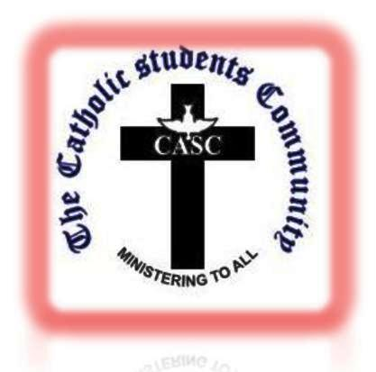

ST. FRANCIS XAVIER CATHOLIC STUDENTS COMMUNITY (CASC)
BE INFORMED THAT THERE WILL BE BIBLE QUIZ & CHURCH DOCTRINE TODAY AT 17:30HOURS AT THE CHAPEL! ALL CASC SMALL CHRISTIAN COMMUNITIES (SCC) SHOULD ATTEND WITHOUT FAIL! PLEASE OBSERVE TIME!!!

